Name:

CODEBOT MISSION 4 LOG - Lesson 3

Pre-Mission Warm-Up
What lines of code play a beep?
What lines of code debounce a button?
Mission 4 Lesson 3 – Animatronics
Mission 4 Objective 8
- Create a new file RobotMoves. Follow the slides to write your code.
What code is needed before the motors will run?
Use your data from Mission 3 Lesson 3. What speed and for how many seconds is needed to move forward 2 feet?
Use your data from Mission 3 Lesson 3. What speed and for how many seconds is needed to turn the robot a full circle?
Mission 4 Objective 9
- Look at the sample code below. Fill out the chart about the while loop for each one.
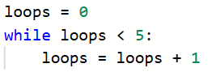
  Control variable
  Initial value
  Specific number
  Increment
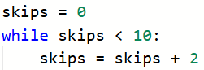
  Control variable
  Initial value
  Specific number
  Increment
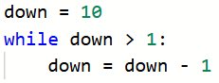
  Control variable
  Initial value
  Specific number
  Increment
Mission 4 Objective 10
Fill out the chart by indicating the lowest and highest integer possible for each function call.
  Function call | Lowest | Highest
  randrange(0, 2)
  randrange(1, 15)
  randrange(100, 1000)
  randrange(10, 101)
Mission 4 Objective 11
What is a function?
How do you create a function?
How do you call a function?
Post-Mission Reflection
What part of this program was a review from earlier programs?
What part of this program was new?

